**Business Process Modelling**

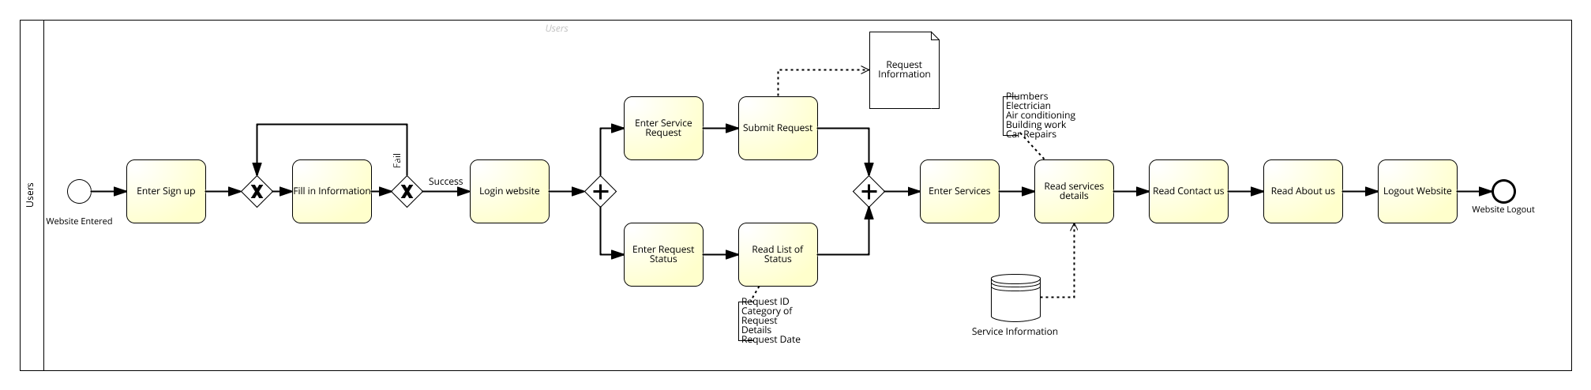These diagrams clear express the structure of our website, business process modelling to help us clearly know the process of the project. The user who has not the account and need to register can according this diagram to register and submit request. This diagram is focus on the main function of service request and login logout system.

This diagram focus on the users’ process. They only need to register into the website and send their request to staff. In addition, they can browse their status of request and update their account.

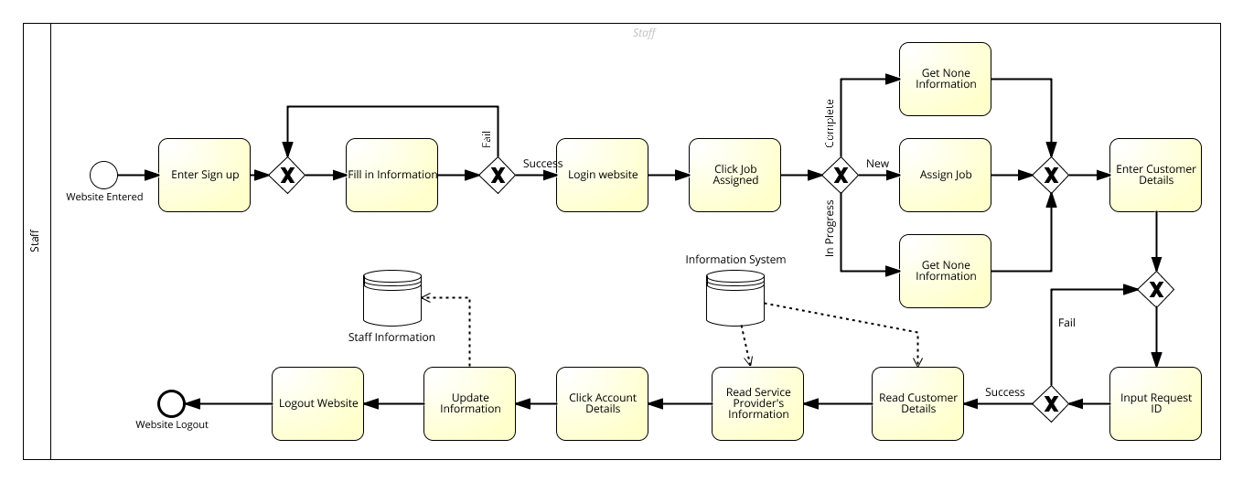

This diagram focus on the staff process. Our website has two kind of register: one is staff and another is user. Staff can see the details information about the customer and service providers, which users cannot read them. In addition, staff can assign the job to service provider and they also can update their own information.